Arvind Gavali College of Engineering, Satara
Department of Computer Science & Engineering

Third Year Feedback
Month: April 2020 – 1st Week
Total Responses: 37 Total Class Strength:64
Feedback Percentage: 52.00%

FACULTY – SUBJECT DISTRIBUTION

Sr. No  . | Subject | Abbrev. | Name of Faculty | Abbrev.
01 | Compiler Design | CD | Mrs.Mandhre R.M. | MRM
02 | Computer Networks | CN | Mrs.Bhosale V.K. | BVK
03 | Elective-V(Artificial Intelligence) | AI | Miss.Mulla S.Y. | MSY
04 | Open Elective-VII (National Social Service) | NSS | Miss.Waghmare S.A. | WSA

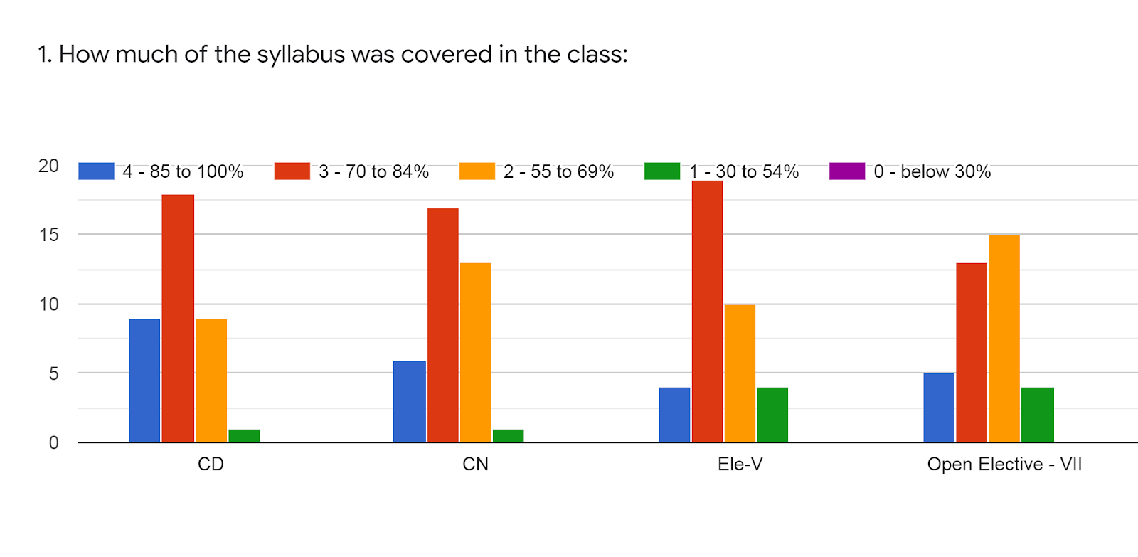

Faculty | MRM | BVK | MSY | WSA | %
Subject | CD | CN | AI | NSS
85 -100 % | 9 | 6 | 4 | 5 | 16%
70 - 84 % | 18 | 16 | 19 | 13 | 44%
55 – 69 % | 9 | 12 | 10 | 15 | 31%
30 – 54 % | 1 | 1 | 4 | 4 | 6%
0- Below 30 % | 0 | 0 | 0 | 0 | 0

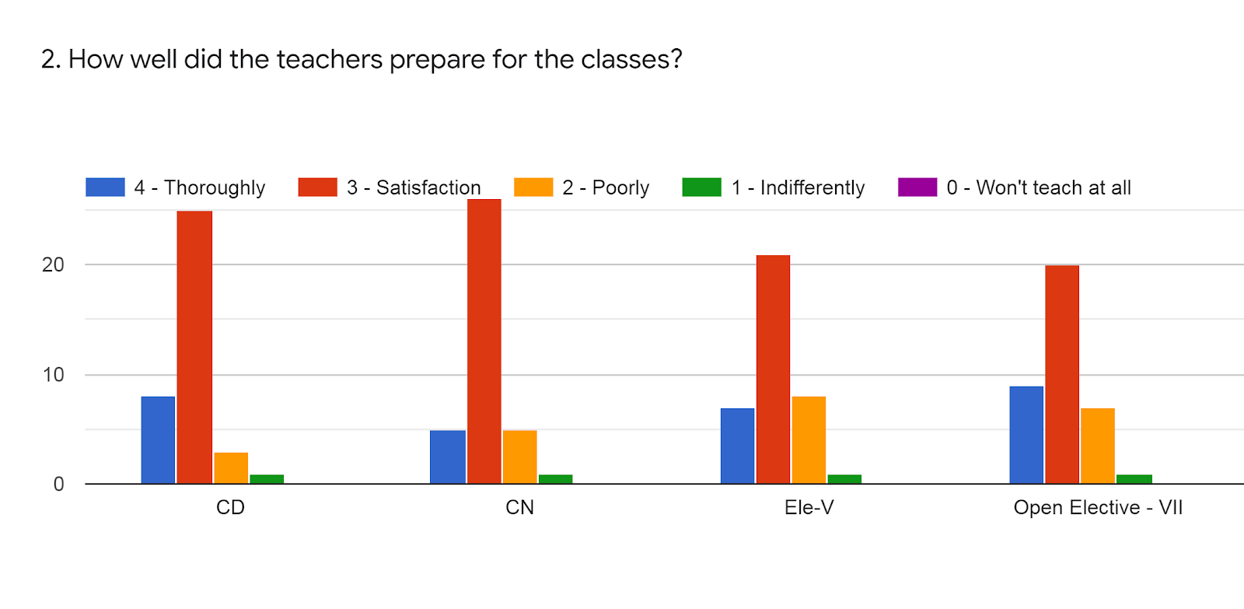
Faculty | MRM | BVK | MSY | WSA | %
Subject | CD | CN | AI | NSS
85 -100 % | 7 | 5 | 8 | 8 | 18%
70 - 84 % | 26 | 26 | 19 | 19 | 60%
55 – 69 % | 3 | 5 | 9 | 9 | 17%
30 – 54 % | 1 | 1 | 1 | 1 | 2%
0- Below 30 % | 0 | 0 | 0 | 0 | 0%

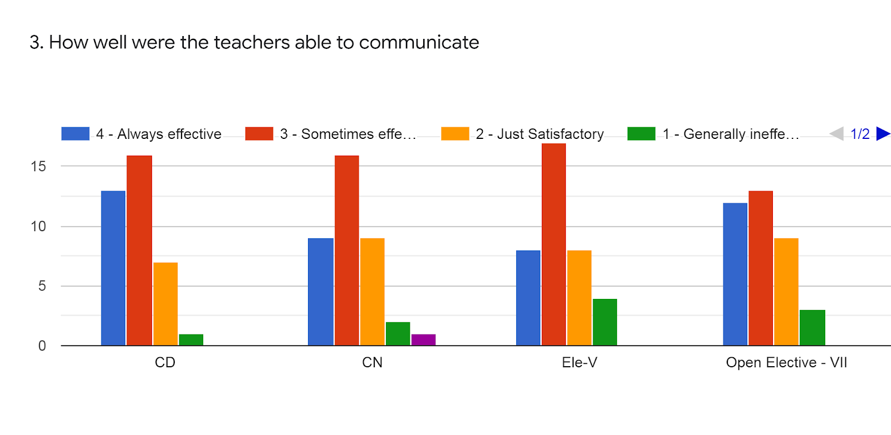

Faculty | MRM | BVK | MSY | WSA | %
Subject | CD | CN | AI | NSS
85 -100 % | 13 | 9 | 7 | 13 | 28%
70 - 84 % | 16 | 16 | 18 | 14 | 43%
55 – 69 % | 7 | 8 | 8 | 9 | 21%
30 – 54 % | 1 | 3 | 5 | 1 | 6%
0- Below 30 % | 0 | 1 | 0 | 0 | 0%

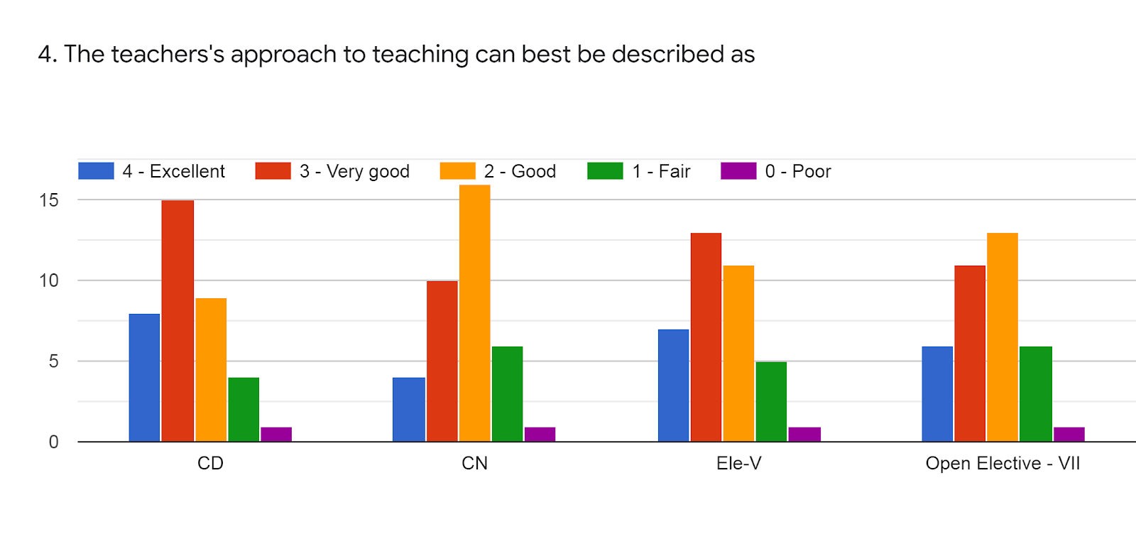
Faculty | MRM | BVK | MSY | WSA | %
Subject | CD | CN | AI | NSS
85 -100 % | 7 | 4 | 7 | 6 | 16%
70 - 84 % | 15 | 10 | 13 | 11 | 33%
55 – 69 % | 9 | 16 | 11 | 13 | 33%
30 – 54 % | 4 | 6 | 5 | 6 | 14%
0- Below 30 % | 1 | 1 | 1 | 1 | 2%

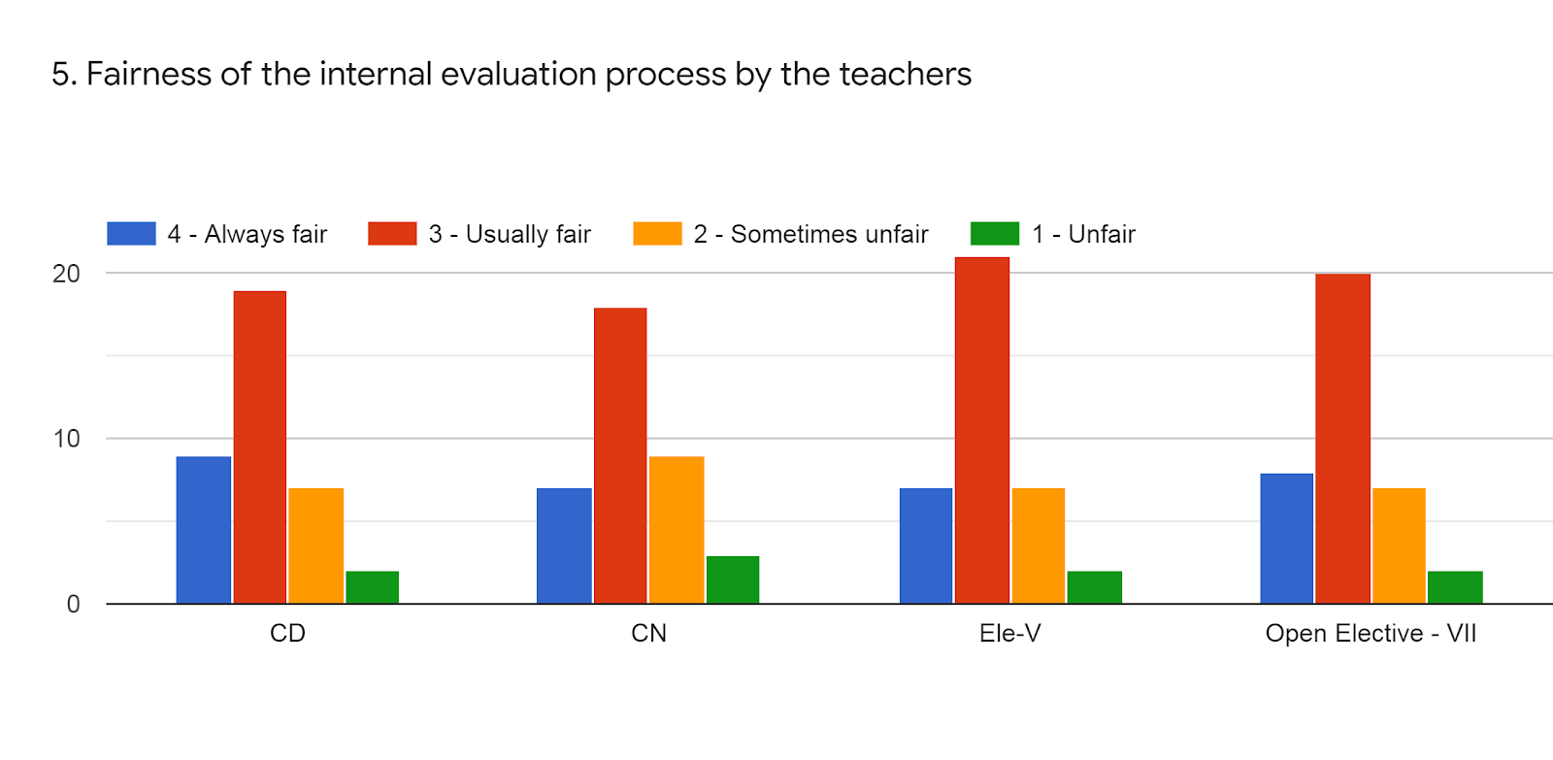

Faculty | MRM | BVK | MSY | WSA | %
Subject | CD | CN | AI | NSS
85 -100 % | 9 | 7 | 7 | 8 | 20%
70 - 84 % | 19 | 17 | 21 | 20 | 52%
55 – 69 % | 7 | 9 | 7 | 7 | 20%
30 – 54 % | 2 | 4 | 2 | 2 | 6%
0- Below 30 % | 0 | 0 | 0 | 0 | 0%

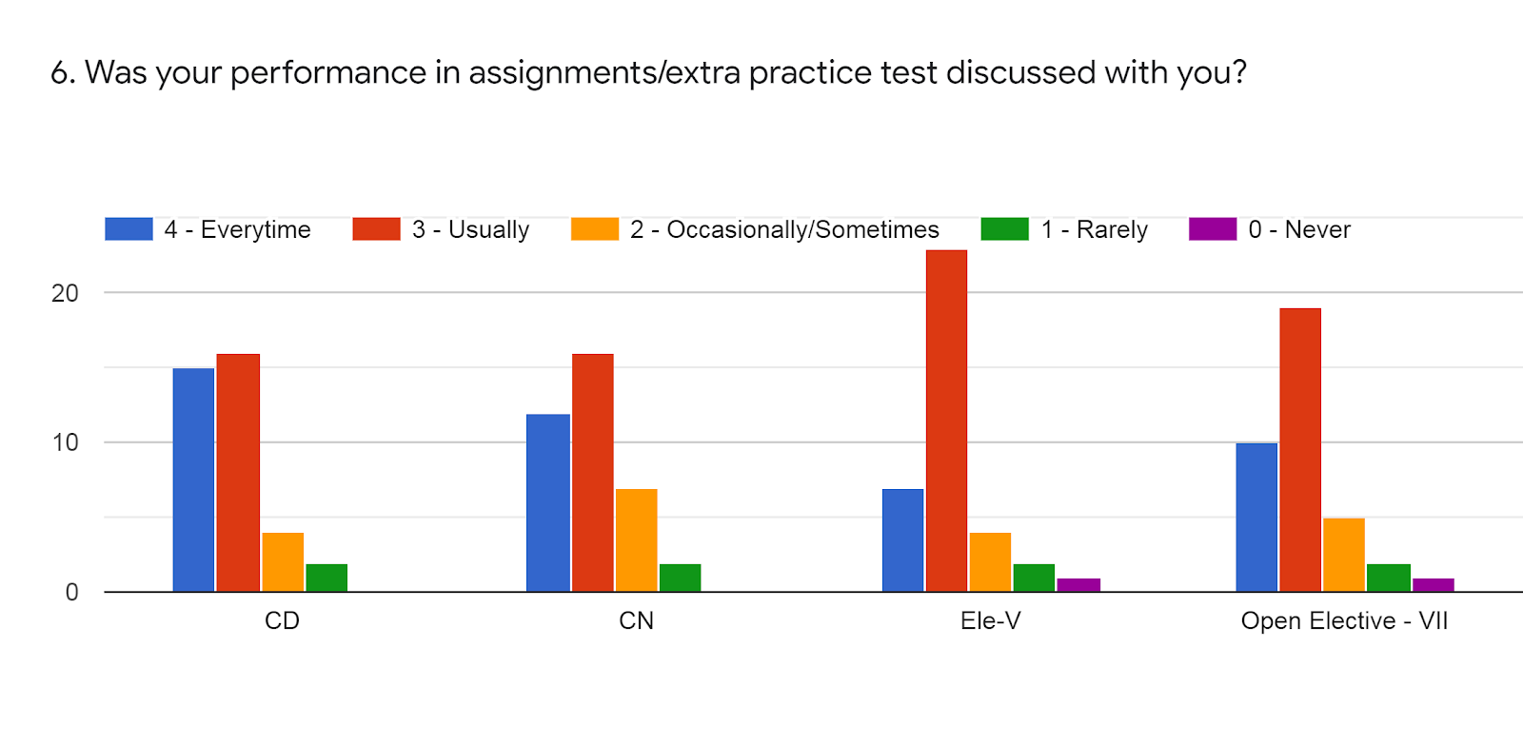

Faculty | MRM | BVK | MSY | WSA | %
Subject | CD | CN | AI | NSS
85 -100 % | 15 | 10 | 6 | 10 | 27%
70 - 84 % | 16 | 16 | 25 | 20 | 52%
55 – 69 % | 4 | 9 | 3 | 4 | 13%
30 – 54 % | 2 | 2 | 2 | 2 | 5%
0- Below 30 % | 0 | 0 | 1 | 1 | 1%

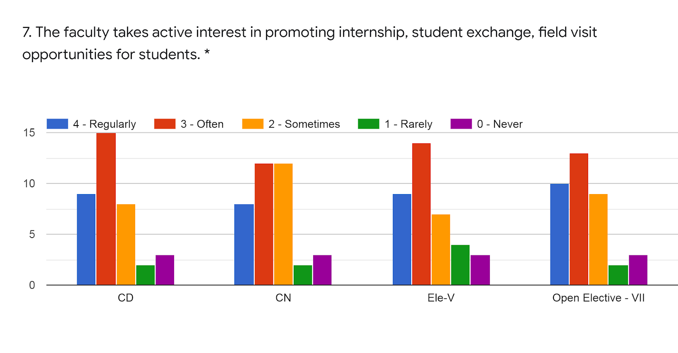

Faculty | MRM | BVK | MSY | WSA | %
Subject | CD | CN | AI | NSS
85 -100 % | 9 | 6 | 9 | 10 | 22%
70 - 84 % | 15 | 13 | 15 | 13 | 37%
55 – 69 % | 8 | 13 | 8 | 9 | 25%
30 – 54 % | 2 | 2 | 3 | 2 | 6%
0- Below 30 % | 3 | 3 | 2 | 3 | 7%

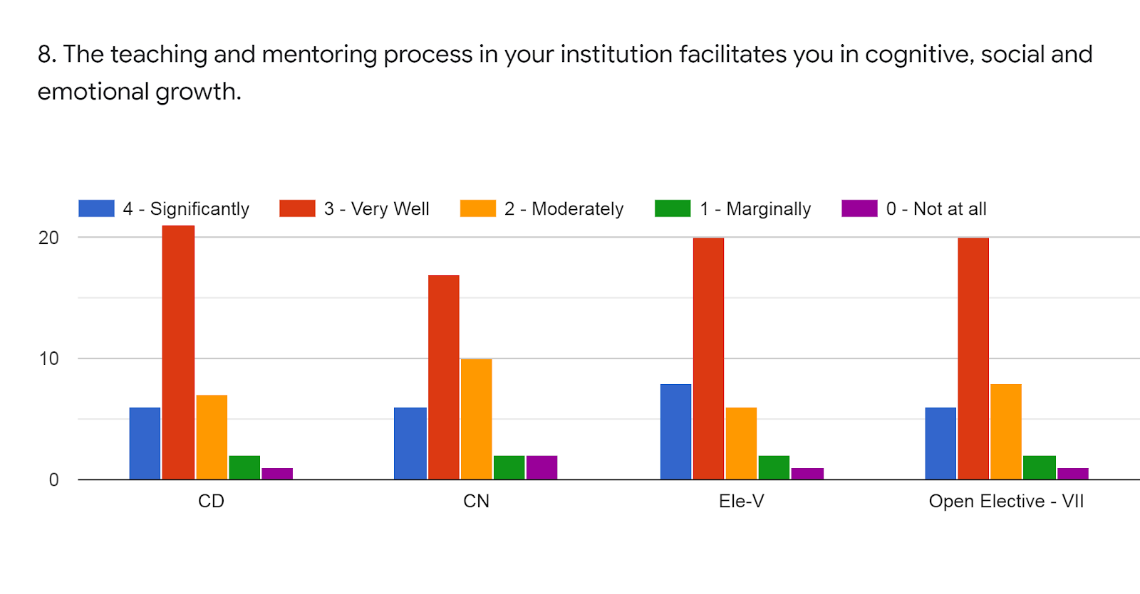

Faculty | MRM | BVK | MSY | WSA | %
Subject | CD | CN | AI | NSS
85 -100 % | 5 | 5 | 6 | 5 | 14%
70 - 84 % | 21 | 17 | 20 | 21 | 53%
55 – 69 % | 8 | 11 | 8 | 8 | 23%
30 – 54 % | 2 | 2 | 2 | 2 | 5%
0- Below 30 % | 1 | 2 | 1 | 1 | 3%

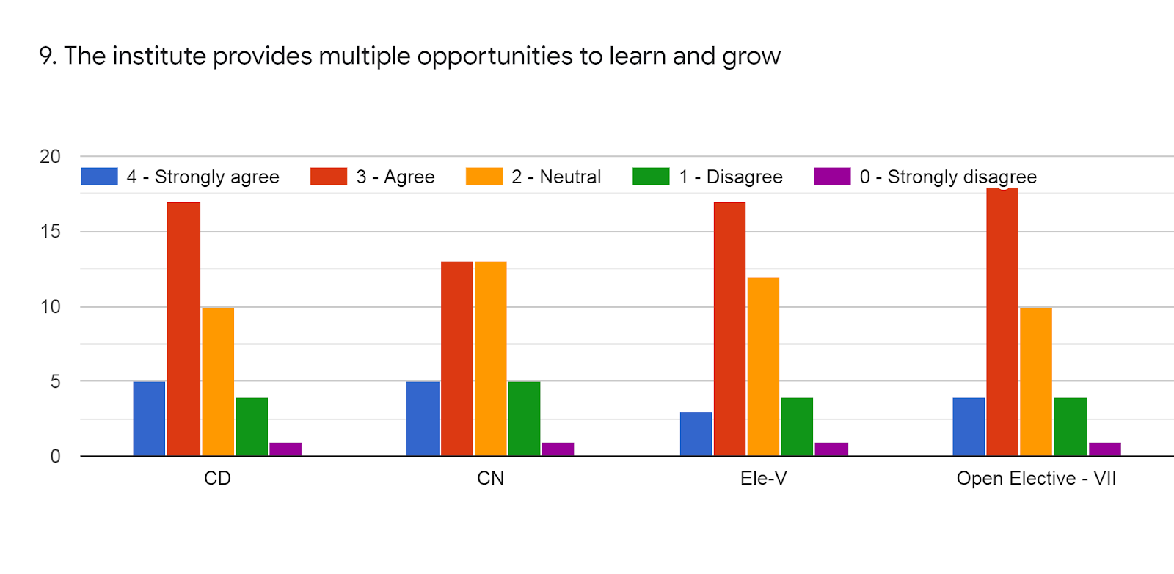

Faculty | MRM | BVK | MSY | WSA | %
Subject | CD | CN | AI | NSS
85 -100 % | 5 | 5 | 3 | 3 | 10%
70 - 84 % | 17 | 13 | 17 | 19 | 44%
55 – 69 % | 10 | 13 | 13 | 10 | 31%
30 – 54 % | 4 | 5 | 3 | 3 | 10%
0- Below 30 % | 1 | 1 | 1 | 2 | 3%

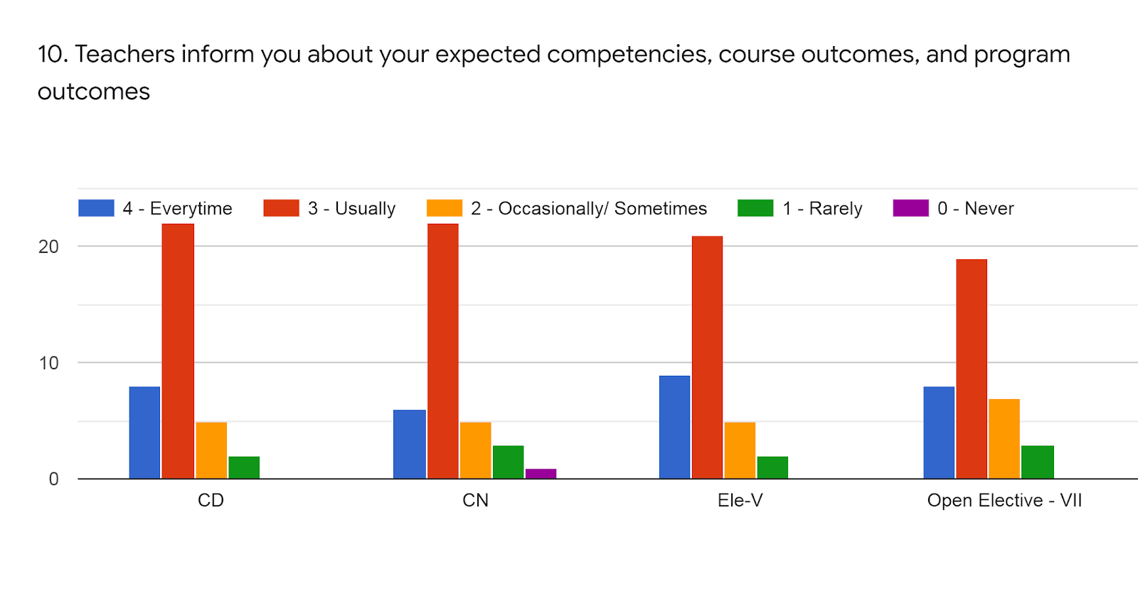

Faculty | MRM | BVK | MSY | WSA | %
Subject | CD | CN | AI | NSS
85 -100 % | 8 | 5 | 9 | 3 | 16%
70 - 84 % | 22 | 23 | 21 | 19 | 57%
55 – 69 % | 5 | 5 | 5 | 10 | 16%
30 – 54 % | 2 | 3 | 2 | 3 | 6%
0- Below 30 % | 0 | 1 | 0 | 2 | 2%

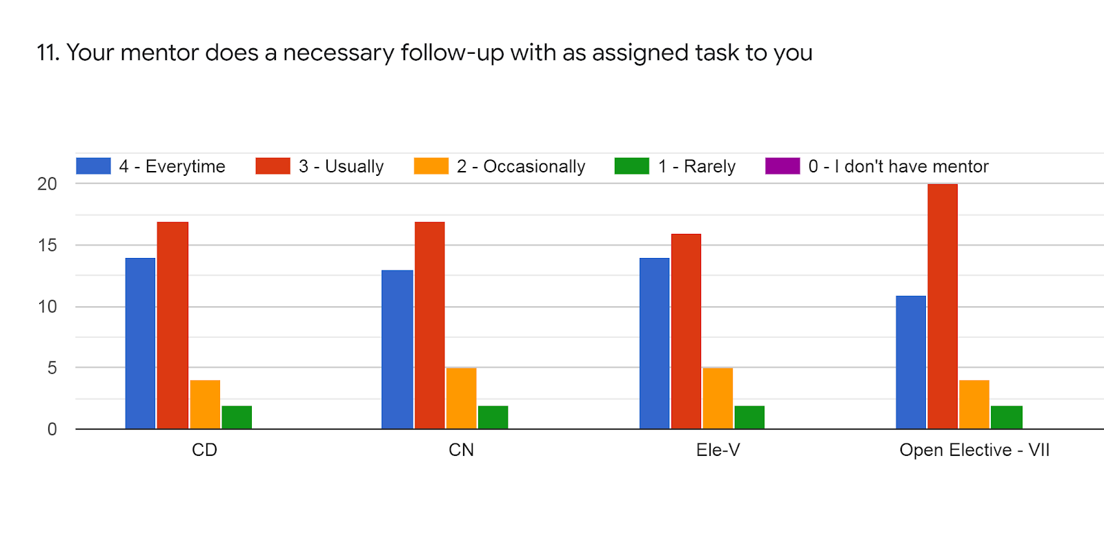

Faculty | MRM | BVK | MSY | WSA | %
Subject | CD | CN | AI | NSS
85 -100 % | 14 | 13 | 14 | 11 | 35%
70 - 84 % | 17 | 17 | 16 | 20 | 47%
55 – 69 % | 4 | 5 | 5 | 4 | 12%
30 – 54 % | 2 | 2 | 2 | 2 | 5%
0- Below 30 % | 0 | 0 | 0 | 0 | 0%

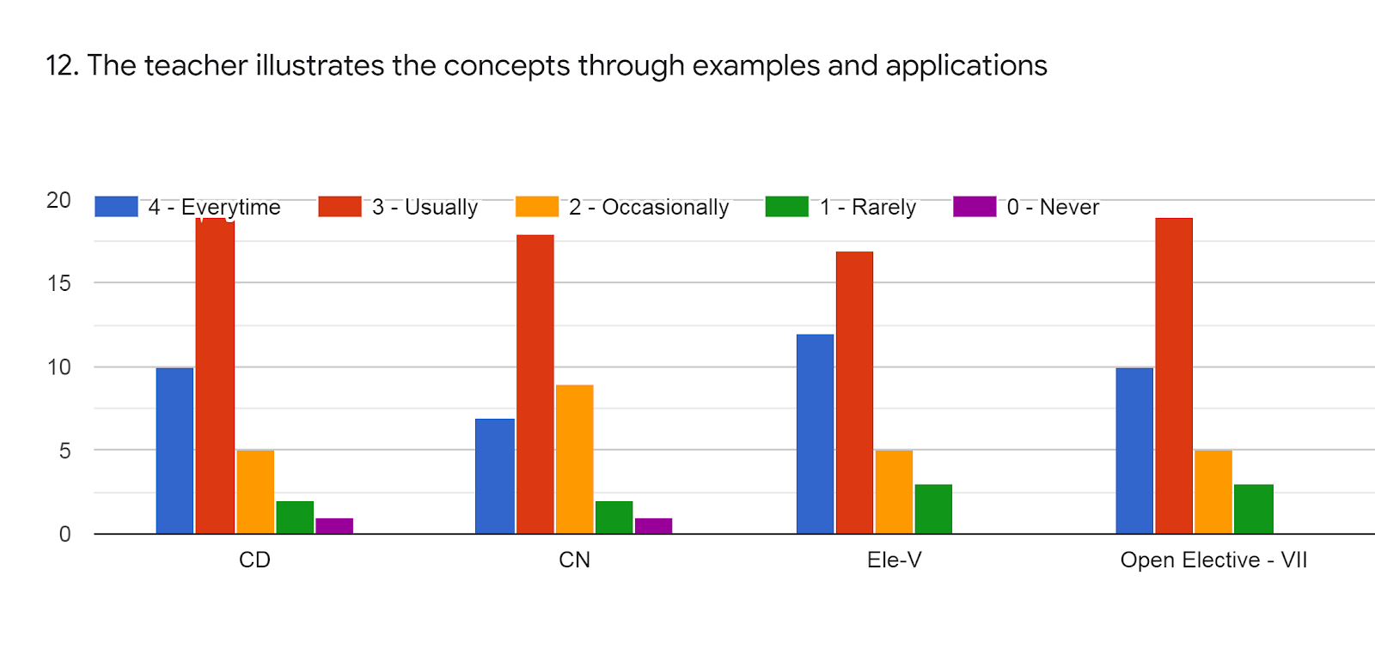

Faculty | MRM | BVK | MSY | WSA | %
Subject | CD | CN | AI | NSS
85 -100 % | 10 | 7 | 13 | 10 | 27%
70 - 84 % | 19 | 17 | 16 | 18 | 47%
55 – 69 % | 5 | 8 | 5 | 5 | 15%
30 – 54 % | 2 | 2 | 3 | 4 | 7%
0- Below 30 % | 1 | 0 | 0 | 0 | 0%

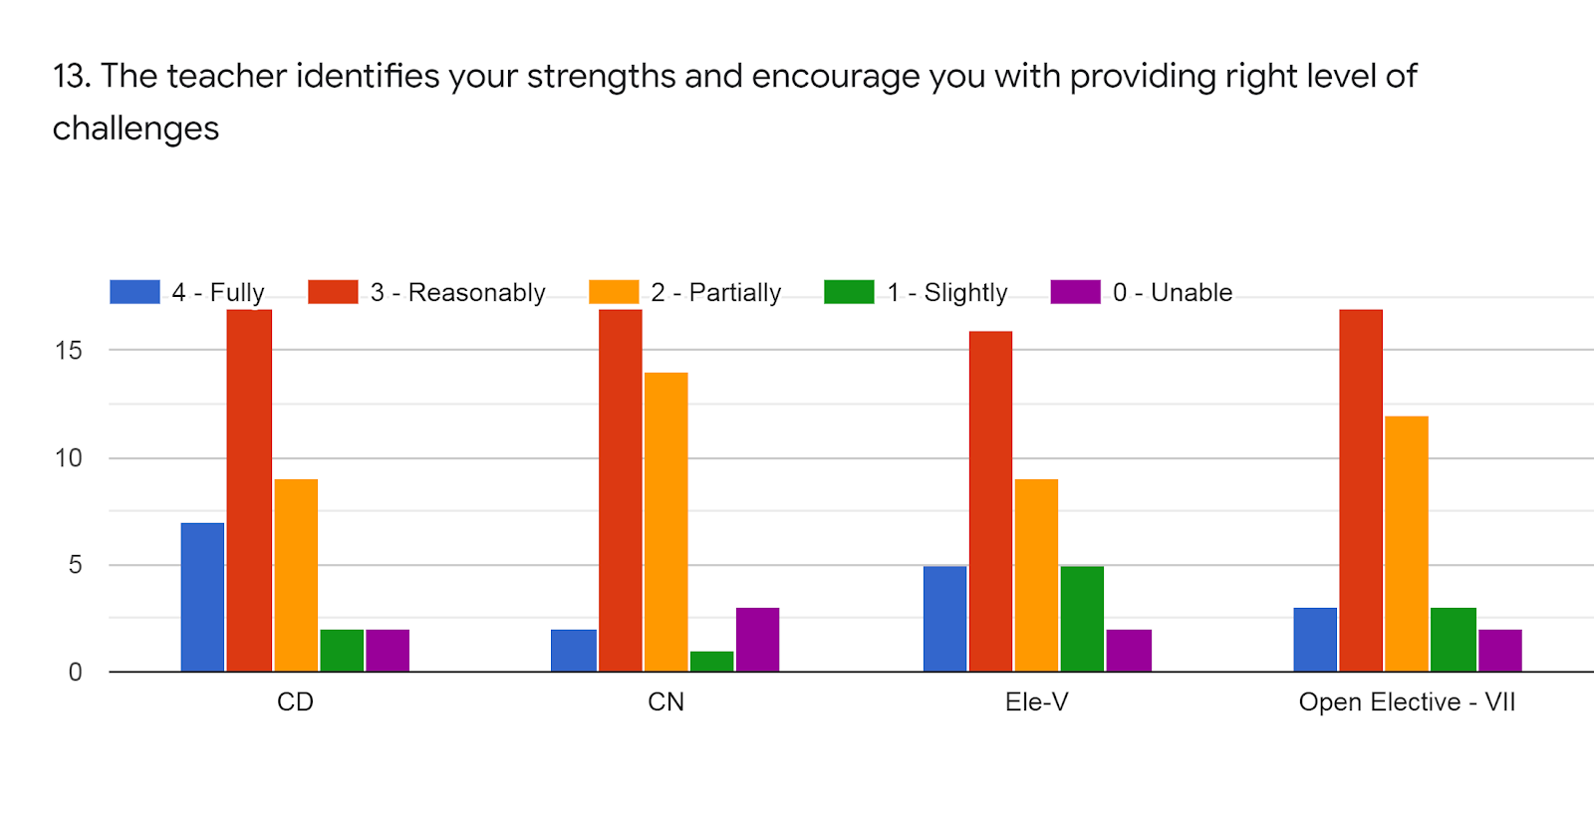
Faculty | MRM | BVK | MSY | WSA | %
Subject | CD | CN | AI | NSS
85 -100 % | 7 | 2 | 5 | 3 | 11%
70 - 84 % | 17 | 17 | 16 | 17 | 45%
55 – 69 % | 9 | 14 | 9 | 12 | 29%
30 – 54 % | 2 | 1 | 5 | 3 | 7%
0- Below 30 % | 2 | 3 | 2 | 2 | 6%

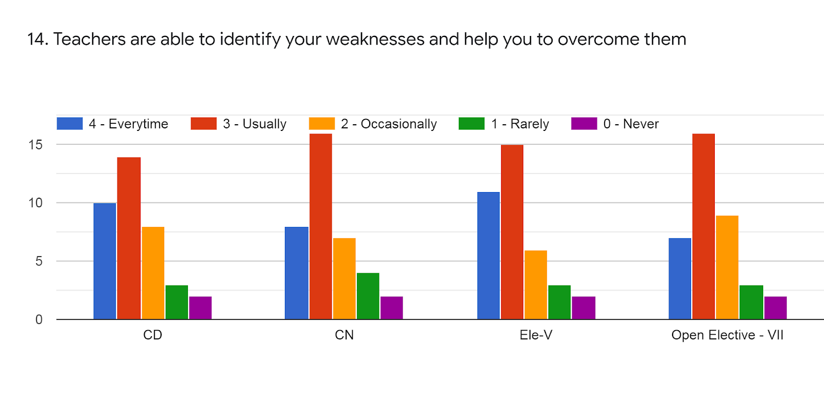
Faculty | MRM | BVK | MSY | WSA | %
Subject | CD | CN | AI | NSS
85 -100 % | 10 | 8 | 11 | 7 | 24%
70 - 84 % | 14 | 16 | 15 | 16 | 41%
55 – 69 % | 8 | 7 | 6 | 9 | 20%
30 – 54 % | 3 | 4 | 3 | 3 | 8%
0- Below 30 % | 2 | 2 | 2 | 2 | 5%

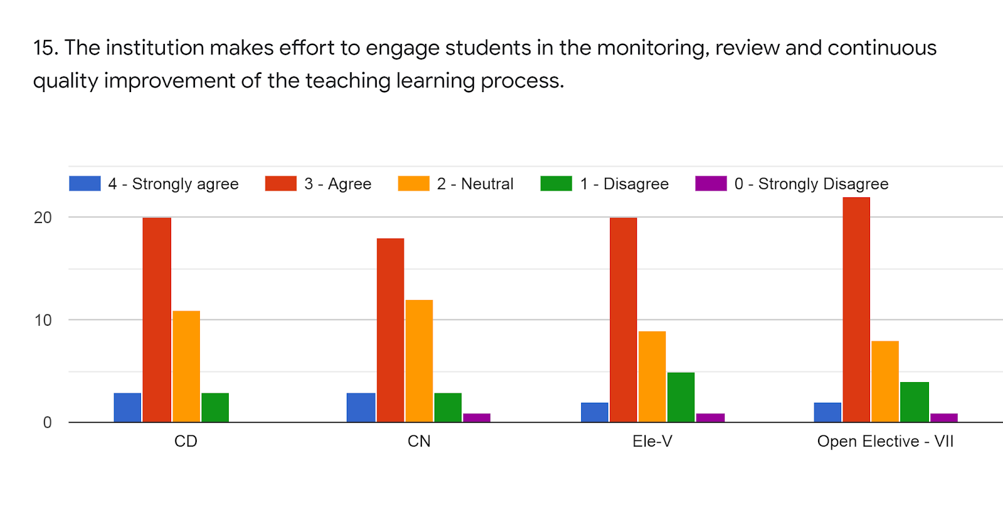

Faculty | MRM | BVK | MSY | WSA | %
Subject | CD | CN | AI | NSS
85 -100 % | 3 | 3 | 2 | 2 | 6%
70 - 84 % | 20 | 18 | 20 | 22 | 54%
55 – 69 % | 11 | 12 | 9 | 8 | 27%
30 – 54 % | 3 | 3 | 5 | 4 | 10%
0- Below 30 % | 0 | 1 | 1 | 1 | 2%

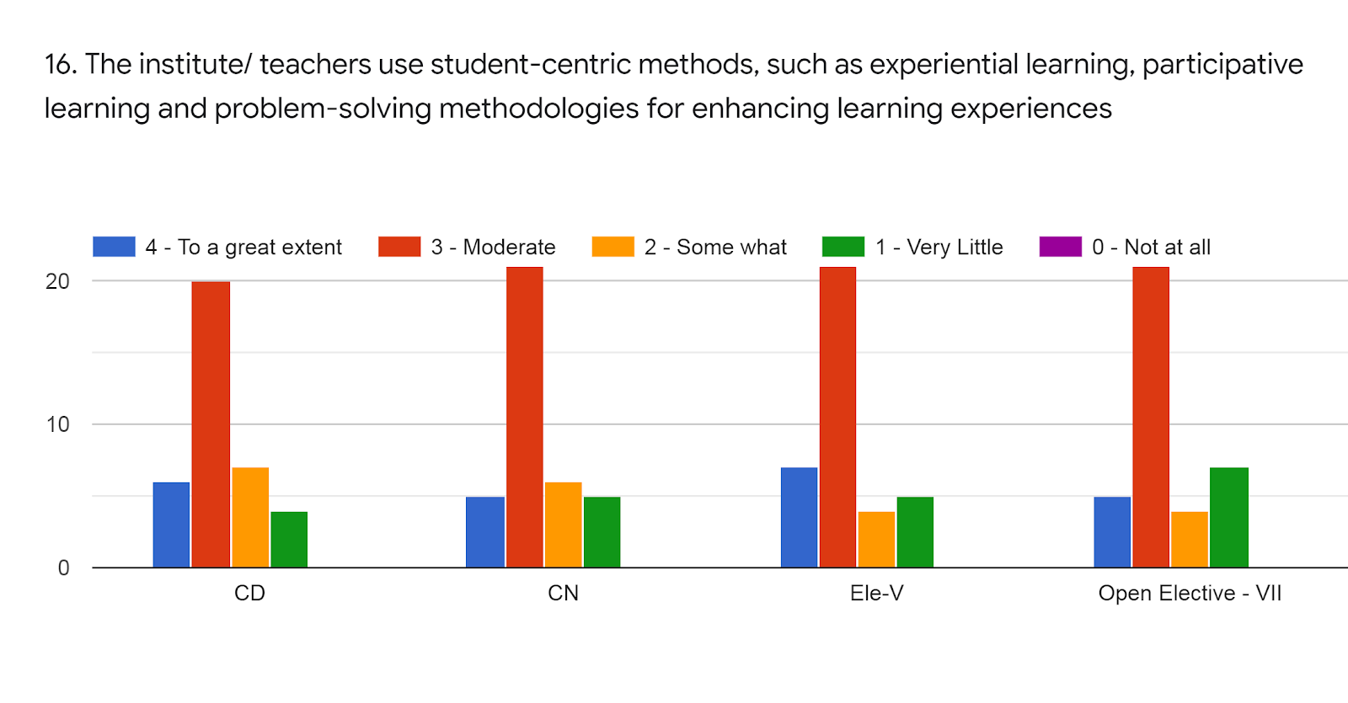
Faculty | MRM | BVK | MSY | WSA | %
Subject | CD | CN | AI | NSS
85 -100 % | 6 | 5 | 7 | 5 | 15%
70 - 84 % | 20 | 21 | 21 | 21 | 56%
55 – 69 % | 7 | 6 | 4 | 4 | 14%
30 – 54 % | 4 | 5 | 5 | 7 | 14%
0- Below 30 % | 0 | 0 | 0 | 0 | 0%

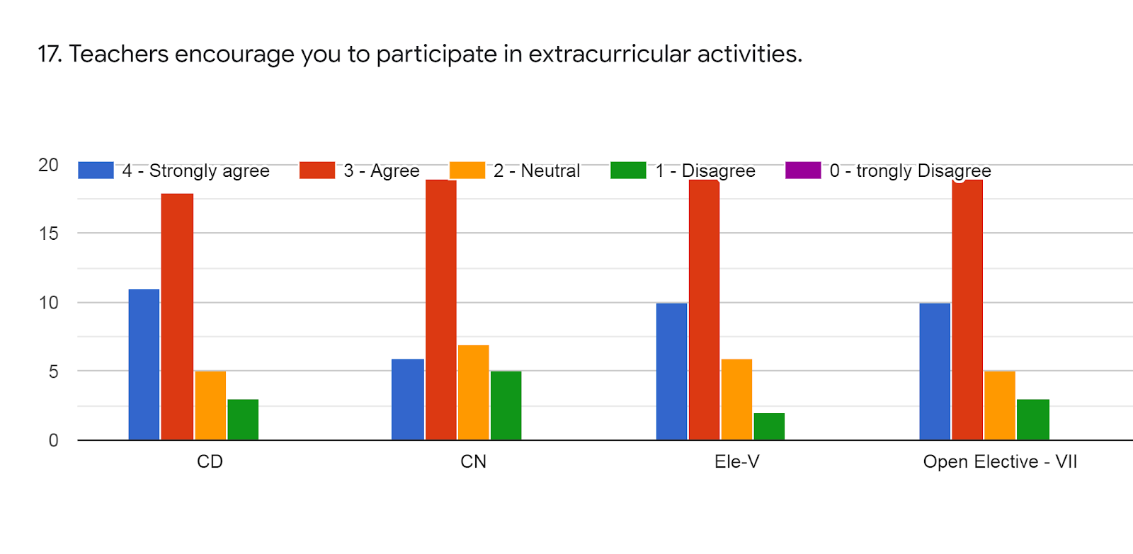

Faculty | MRM | BVK | MSY | WSA | %
Subject | CD | CN | AI | NSS
85 -100 % | 11 | 6 | 10 | 5 | 21%
70 - 84 % | 17 | 18 | 19 | 21 | 50%
55 – 69 % | 5 | 6 | 6 | 4 | 14%
30 – 54 % | 4 | 5 | 2 | 7 | 12%
0- Below 30 % | 0 | 0 | 0 | 0 | 0%

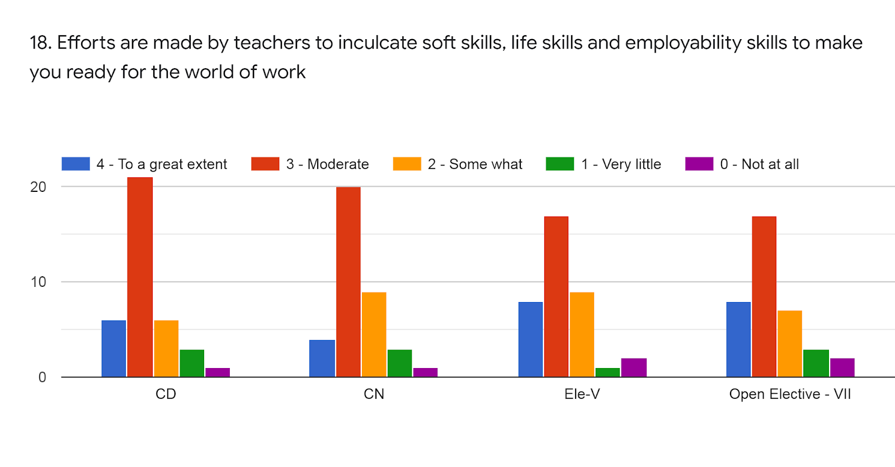

Faculty | MRM | BVK | MSY | WSA | %
Subject | CD | CN | AI | NSS
85 -100 % | 6 | 4 | 8 | 8 | 17%
70 - 84 % | 21 | 20 | 17 | 19 | 52%
55 – 69 % | 6 | 9 | 9 | 5 | 19%
30 – 54 % | 3 | 3 | 1 | 3 | 6%
0- Below 30 % | 1 | 1 | 2 | 2 | 4%

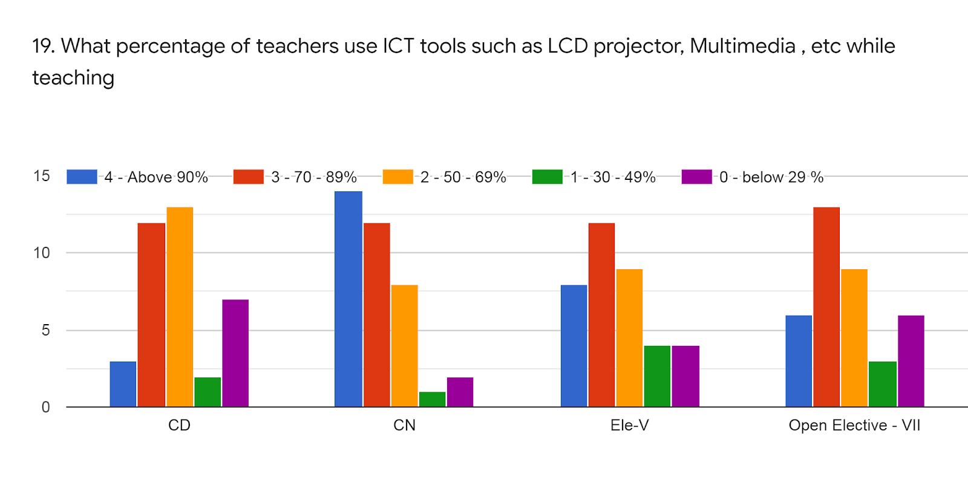

Faculty | MRM | BVK | MSY | WSA | %
Subject | CD | CN | AI | NSS
85 -100 % | 3 | 12 | 8 | 6 | 19%
70 - 84 % | 11 | 12 | 12 | 12 | 31%
55 – 69 % | 12 | 8 | 9 | 9 | 25%
30 – 54 % | 3 | 2 | 4 | 4 | 8%
0- Below 30 % | 8 | 3 | 4 | 6 | 14%

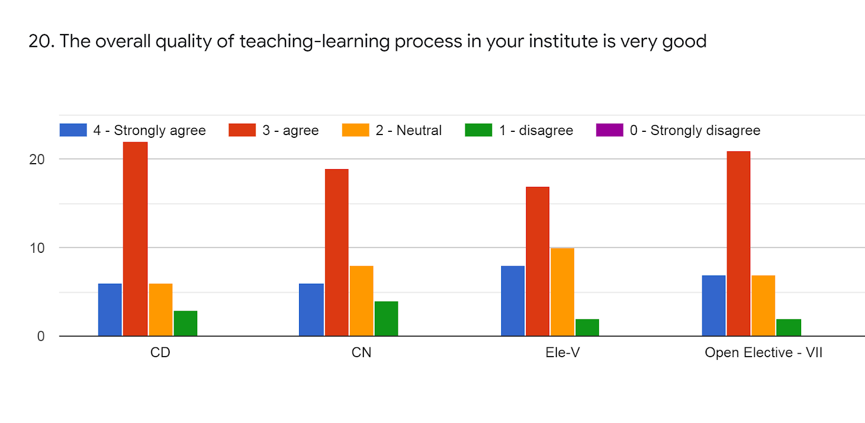

Faculty | MRM | BVK | MSY | WSA | %
Subject | CD | CN | AI | NSS
85 -100 % | 6 | 6 | 8 | 7 | 18%
70 - 84 % | 22 | 19 | 18 | 22 | 54%
55 – 69 % | 6 | 8 | 10 | 7 | 20%
30 – 54 % | 3 | 4 | 1 | 1 | 6%
0- Below 30 % | 0 | 0 | 0 | 0 | 0%

- Give 3 observations/ suggestions to improve the overall teaching-learning experience of respective teachers.
  - Give sufficient time for submission
  - Provide proper notes.

  - Provide Sample university question paper
  - Used ICT panel most of the time
  - Overall teaching learning process is good

OVERALL ANALYSIS

Sub | Faculty | Appreciation | Suggestions for  improvement
CD | MRM | Well Preparation for lecture, Well Communication, Promoting internship, student exchange, field visit opportunities for students | Field Visits
CN | BVK | Well Preparation for lecture, Inform student about his/her expected competencies, course outcomes, and program outcomes, Use of ICT, Syllabus coverage | Use of ICT
AI | MSY | 70-84 % syllabus was covered in the class: Well Communication, Fairness of the internal evaluation Follow up of task, Teacher illustrates the concepts through examples and applications | -
NSS | WSA | Provides multiple opportunities to learn and grow , Mentor does a necessary follow-up with as assigned task , Teacher illustrates the concepts through examples and applications | -

