Arvind Gavali College of Engineering, Satara
Department of Computer Science & Engineering

Final Year Feedback
Month: April 2020 – 1st Week
Total Responses:12 Total Class Strength:43
Feedback Percentage: 27%

FACULTY – SUBJECT DISTRIBUTION

Sr. No  . | Subject | Abbrev. | Name of Faculty | Abbrev.
01 | Design & Analysis of Algorithms | DAA | Mrs.Mandhre R.M. | MRM
02 | Probability & Statistics | PS | Miss.Mulla S.Y. | MSY
03 | Operating System | OS | Mr. Mohite V. | VM
04 | Elective-I(Object Oriented  Programming in Java) | OOP | Miss.Gaikwad P.L. | GPL
05 | Elective-II(Numerical Methods) | NM | Miss.Bhosale P.R. | BPR

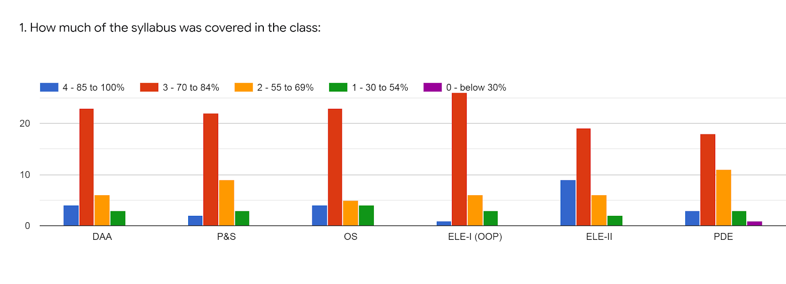

Faculty | MRM | MSY | MV | GPL | BPR | MV | %
Subject | DAA | PS | OS | OOP(ELE-I) | NM(ELE-II) | PD
85 -100 % | 4 | 2 | 4 | 1 | 9 | 3 | 12%
70 - 84 % | 23 | 22 | 23 | 26 | 19 | 17 | 70%
55 – 69 % | 6 | 9 | 5 | 6 | 6 | 12 | 23%
30 – 54 % | 3 | 3 | 4 | 3 | 2 | 3 | 9%
0- Below 30 % | 0 | 0 | 0 | 0 | 0 | 1 | 0.5%
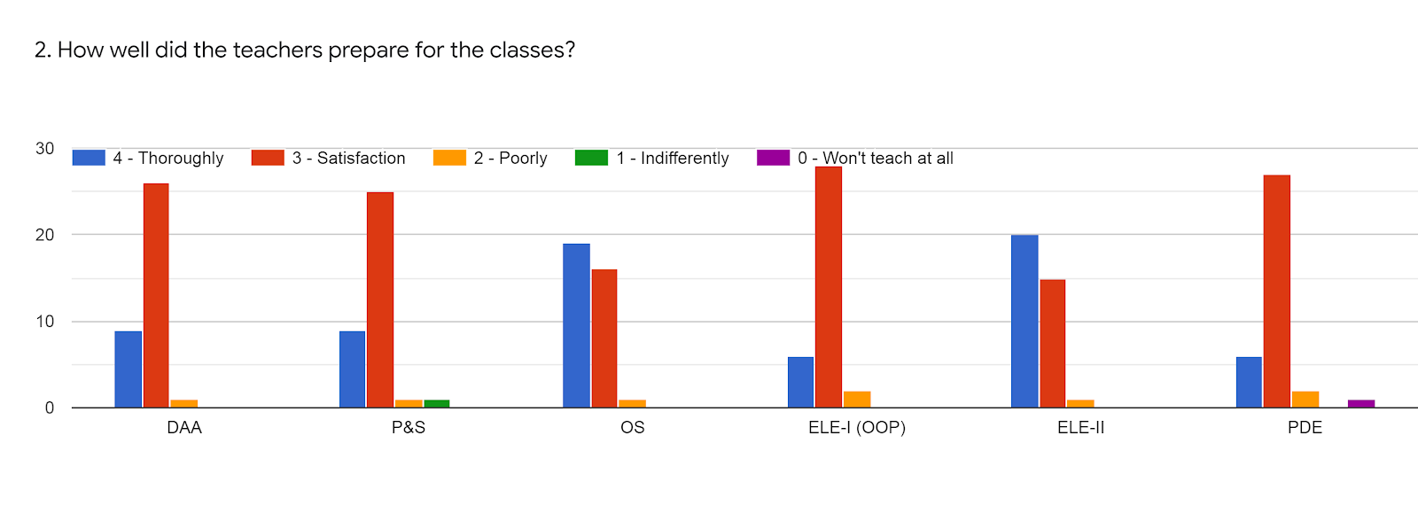

Faculty | MRM | MSY | MV | GPL | BPR | MV | %
Subject | DAA | PS | OS | OOP(ELE-I) | NM(ELE-II) | PD
85 -100 % | 8 | 9 | 19 | 6 | 20 | 6 | 36%
70 - 84 % | 27 | 25 | 16 | 27 | 15 | 26 | 73%
55 – 69 % | 1 | 1 | 1 | 3 | 1 | 3 | 5%
30 – 54 % | 0 | 1 | 0 | 0 | 0 | 0 | 5%
0- Below 30 % | 0 | 0 | 0 | 0 | 0 | 1 | 5%

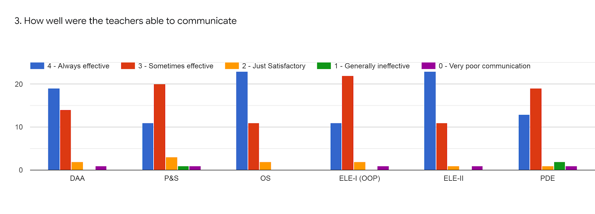

Faculty | MRM | MSY | MV | GPL | BPR | MV | %
Subject | DAA | PS | OS | OOP(ELE-I) | NM(ELE-II) | PD
85 -100 % | 18 | 11 | 21 | 11 | 21 | 15 | 52%
70 - 84 % | 15 | 20 | 12 | 21 | 13 | 17 | 52%
55 – 69 % | 2 | 3 | 3 | 3 | 1 | 1 | 7%
30 – 54 % | 0 | 1 | 0 | 0 | 0 | 2 | 1%
0- Below 30 % | 1 | 1 | 0 | 1 | 1 | 1 | 2%

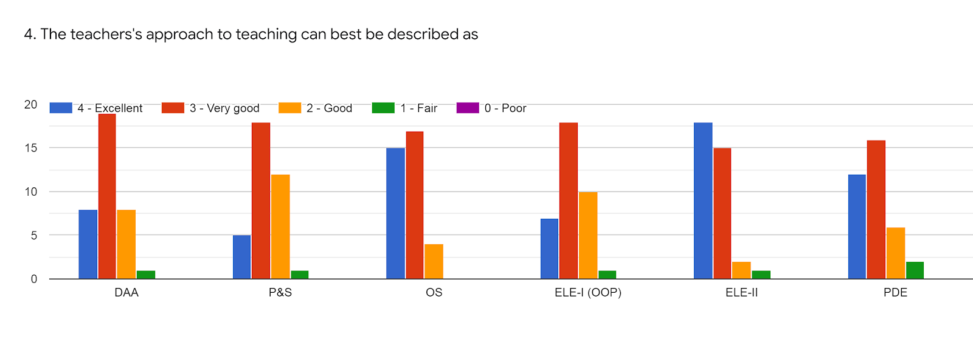
Faculty | MRM | MSY | MV | GPL | BPR | MV | %
Subject | DAA | PS | OS | OOP(ELE-I) | NM(ELE-II) | PD
85 -100 % | 8 | 5 | 15 | 7 | 16 | 13 | 34%
70 - 84 % | 18 | 17 | 17 | 17 | 15 | 14 | 52%
55 – 69 % | 8 | 12 | 4 | 10 | 3 | 6 | 23%
30 – 54 % | 2 | 2 | 0 | 2 | 2 | 3 | 5%
0- Below 30 % | 0 | 0 | 0 | 0 | 0 | 0 | 0%

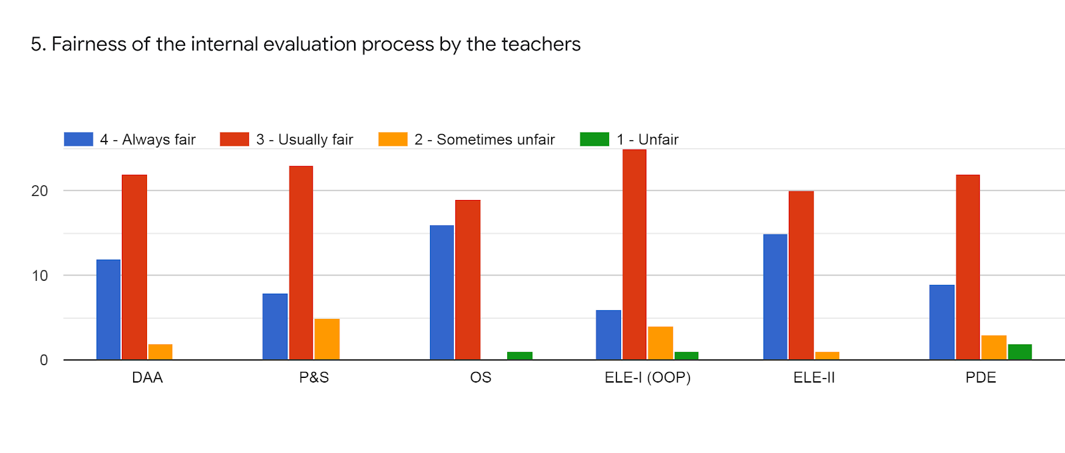

Faculty | MRM | MSY | MV | GPL | BPR | MV | %
Subject | DAA | PS | OS | OOP(ELE-I) | NM(ELE-II) | PD
85 -100 % | 13 | 9 | 16 | 7 | 15 | 9 | 37%
70 – 84 % | 22 | 24 | 19 | 26 | 20 | 22 | 71%
55 – 69 % | 1 | 3 | 0 | 2 | 0 | 3 | 4%
30 – 54 % | 0 | 0 | 1 | 1 | 1 | 2 | 2%
0- Below 30 % | 0 | 0 | 0 | 0 | 0 | 0 | 0%

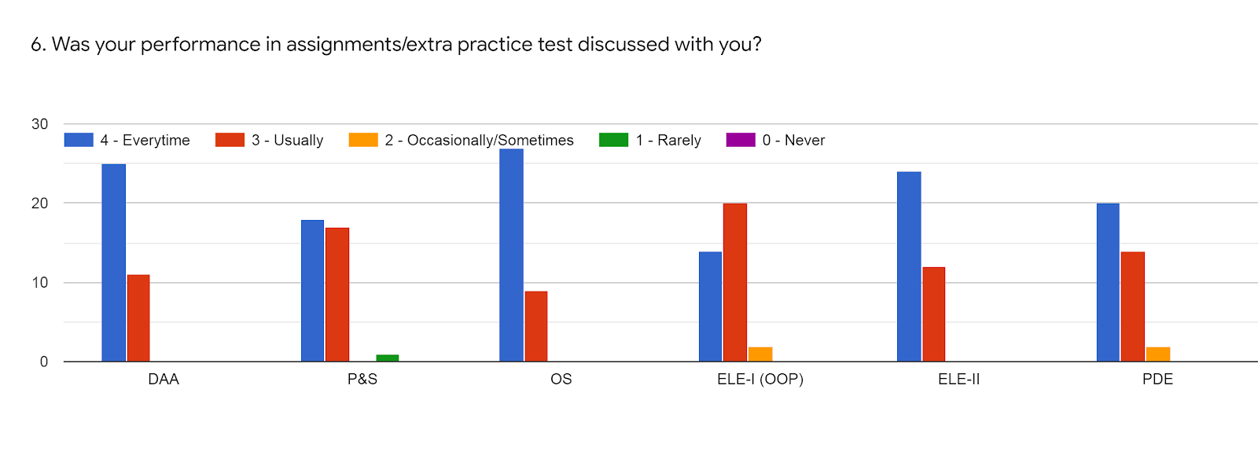

Faculty | MRM | MSY | MV | GPL | BPR | MV | %
Subject | DAA | PS | OS | OOP(ELE-I) | NM(ELE-II) | PD
85 -100 % | 24 | 18 | 27 | 14 | 9 | 14 | 57%
70 - 84 % | 12 | 17 | 9 | 20 | 19 | 20 | 52%
55 – 69 % | 0 | 0 | 0 | 2 | 6 | 2 | 5%
30 – 54 % | 0 | 1 | 0 | 0 | 0 | 0 | 0.5%
0- Below 30 % | 0 | 0 | 0 | 0 | 0 | 0 | 0%

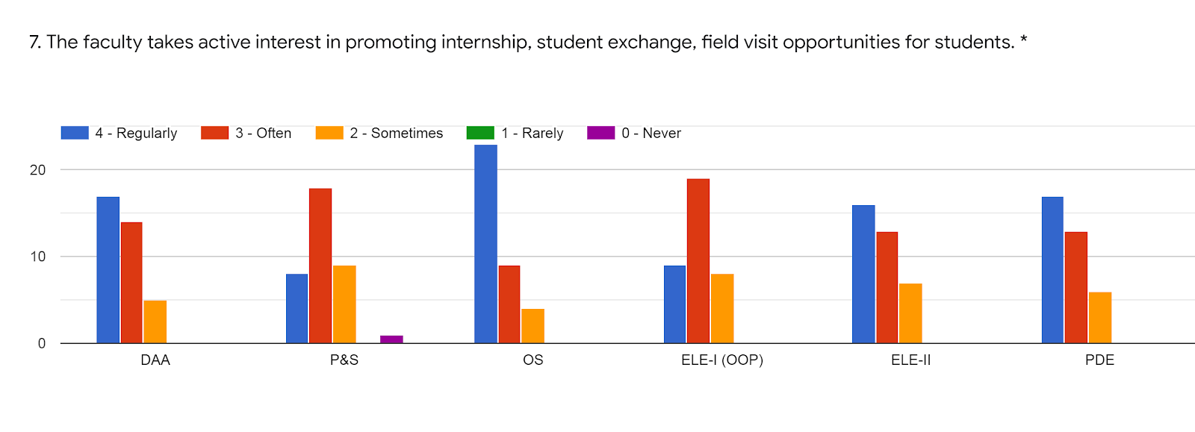

Faculty | MRM | MSY | MV | GPL | BPR | MV | %
Subject | DAA | PS | OS | OOP(ELE-I) | NM(ELE-II) | PD
85 -100 % | 13 | 7 | 23 | 9 | 14 | 16 | 44%
70 - 84 % | 18 | 19 | 9 | 19 | 16 | 14 | 51%
55 – 69 % | 5 | 9 | 4 | 8 | 6 | 6 | 20%
30 – 54 % | 0 | 0 | 0 | 0 | 0 | 0 | 0%
0- Below 30 % | 0 | 1 | 0 | 0 | 0 | 0 | 5%

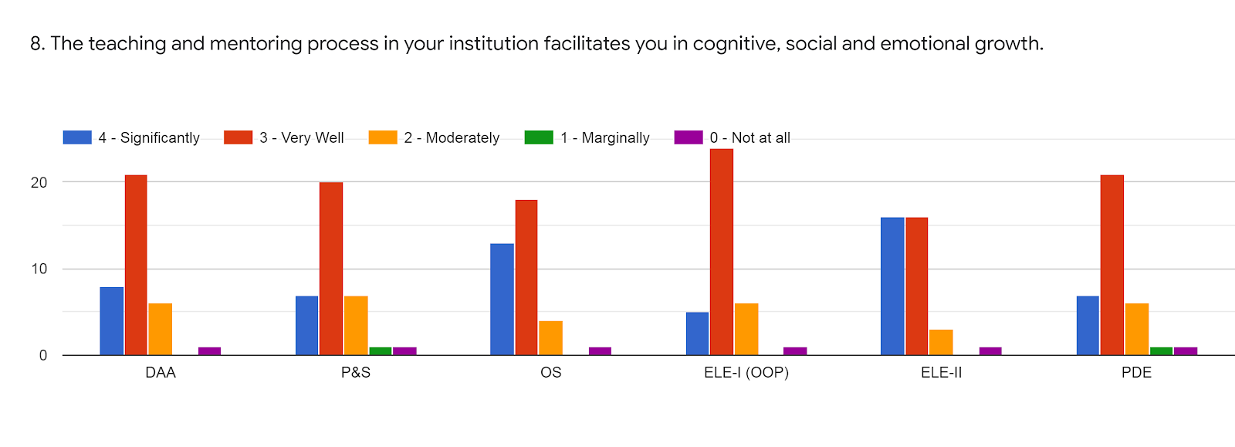

Faculty | MRM | MSY | MV | GPL | BPR | MV | %
Subject | DAA | PS | OS | OOP(ELE-I) | NM(ELE-II) | PD
85 -100 % | 9 | 8 | 12 | 5 | 16 | 8 | 31%
70 - 84 % | 20 | 20 | 18 | 24 | 16 | 20 | 63%
55 – 69 % | 6 | 5 | 5 | 6 | 3 | 6 | 16%
30 – 54 % | 0 | 1 | 0 | 0 | 0 | 1 | 5%
0- Below 30 % | 1 | 1 | 1 | 1 | 1 | 1 | 3%

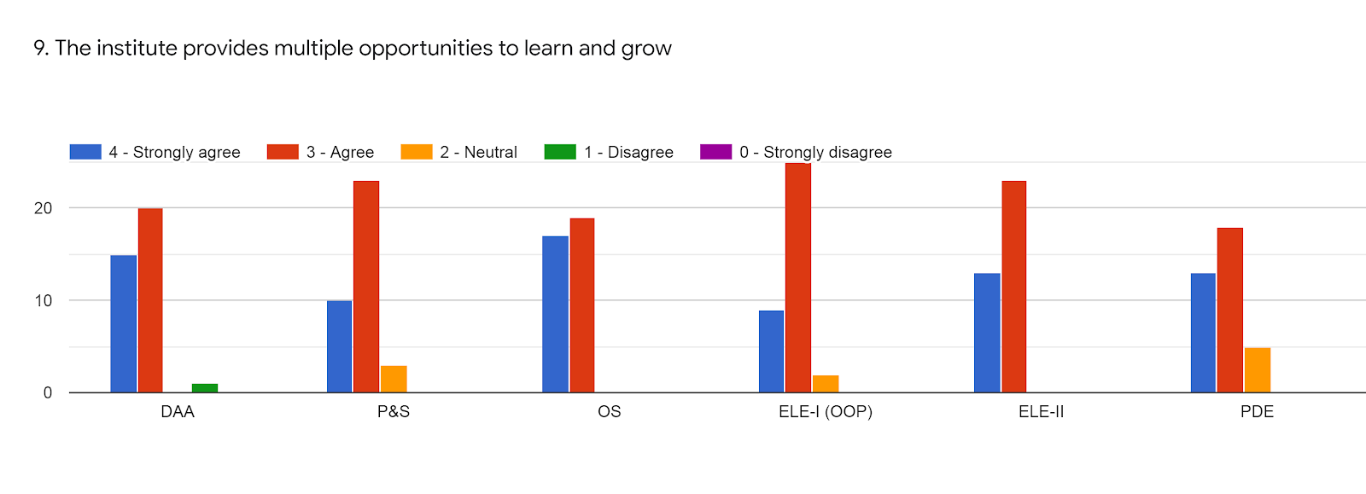

Faculty | MRM | MSY | MV | GPL | BPR | MV | %
Subject | DAA | PS | OS | OOP(ELE-I) | NM(ELE-II) | PD
85 -100 % | 15 | 10 | 18 | 9 | 13 | 13 | 42%
70 - 84 % | 20 | 23 | 19 | 25 | 23 | 18 | 69%
55 – 69 % | 0 | 3 | 0 | 2 | 0 | 5 | 5%
30 – 54 % | 1 | 0 | 0 | 0 | 0 | 0 | 0.5%
0- Below 30 % | 0 | 0 | 0 | 0 | 0 | 0 | 0%

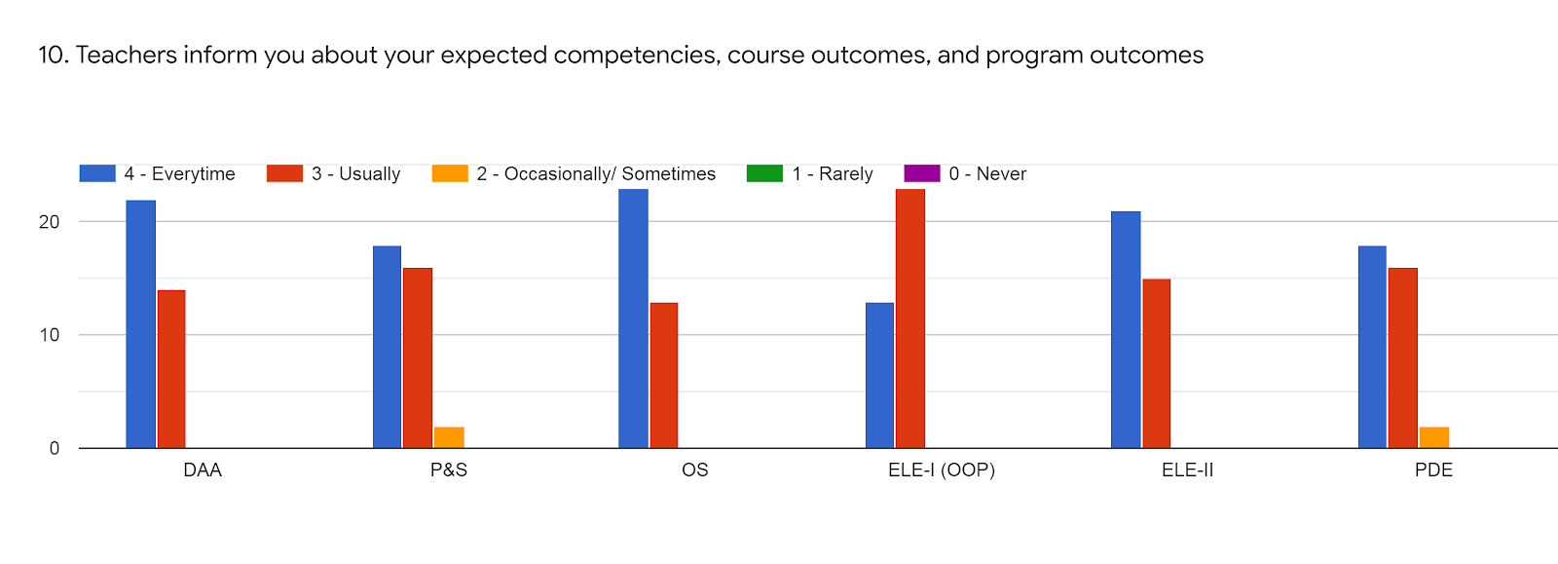

Faculty | MRM | MSY | MV | GPL | BPR | MV | %
Subject | DAA | PS | OS | OOP(ELE-I) | NM(ELE-II) | PD
85 -100 % | 21 | 19 | 22 | 13 | 21 | 19 | 62%
70 - 84 % | 15 | 15 | 14 | 23 | 15 | 15 | 52%
55 – 69 % | 0 | 2 | 0 | 0 | 0 | 2 | 2%
30 – 54 % | 0 | 0 | 0 | 0 | 0 | 0 | 0%
0- Below 30 % | 0 | 0 | 0 | 0 | 0 | 0 | 0%

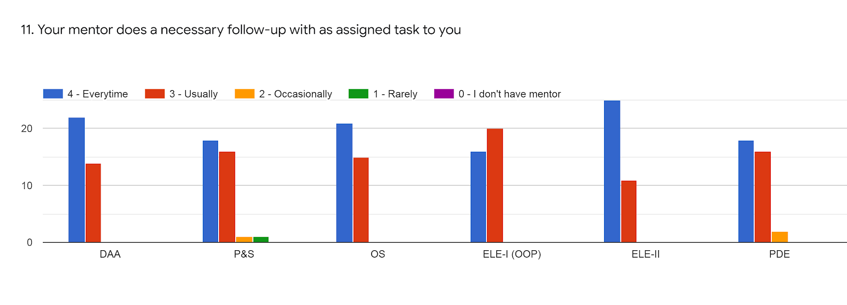

Faculty | MRM | MSY | MV | GPL | BPR | MV | %
Subject | DAA | PS | OS | OOP(ELE-I) | NM(ELE-II) | PD
85 -100 % | 22 | 18 | 20 | 16 | 25 | 19 | 64%
70 - 84 % | 14 | 16 | 16 | 20 | 11 | 15 | 49%
55 – 69 % | 0 | 1 | 0 | 0 | 0 | 2 | 1%
30 – 54 % | 0 | 1 | 0 | 0 | 0 | 0 | 0.5%
0- Below 30 % | 0 | 0 | 0 | 0 | 0 | 0 | 0

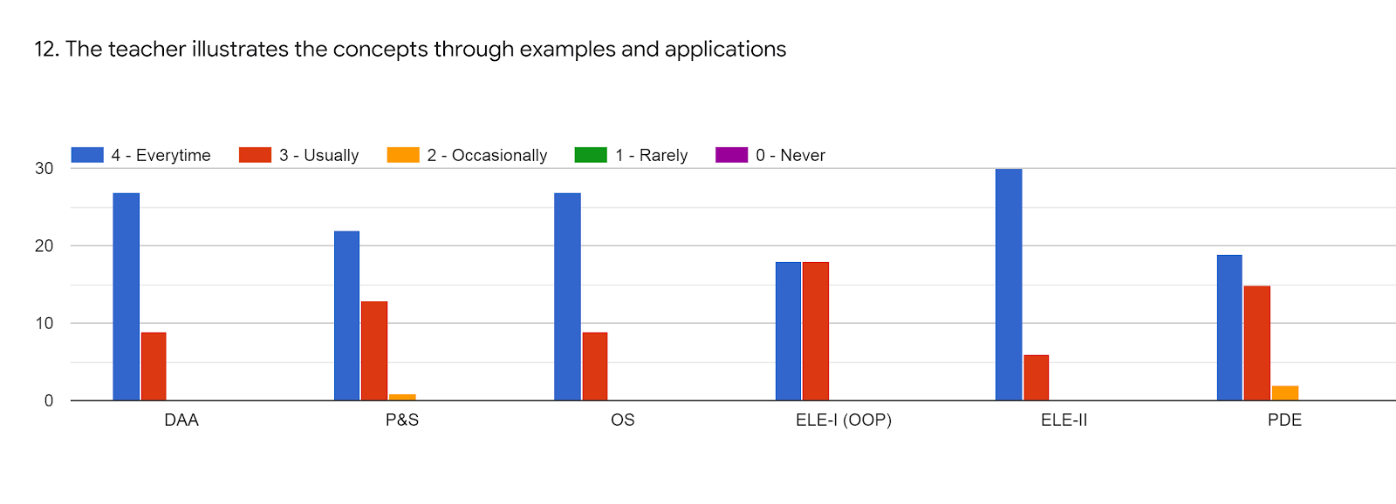

Faculty | MRM | MSY | MV | GPL | BPR | MV | %
Subject | DAA | PS | OS | OOP(ELE-I) | NM(ELE-II) | PD
85 -100 % | 26 | 23 | 26 | 18 | 30 | 18 | 76%
70 - 84 % | 10 | 12 | 10 | 18 | 6 | 16 | 38%
55 – 69 % | 0 | 1 | 0 | 0 | 0 | 2 | 1%
30 – 54 % | 0 | 0 | 0 | 0 | 0 | 0 | 0%
0- Below 30 % | 0 | 0 | 0 | 0 | 0 | 0 | 0%

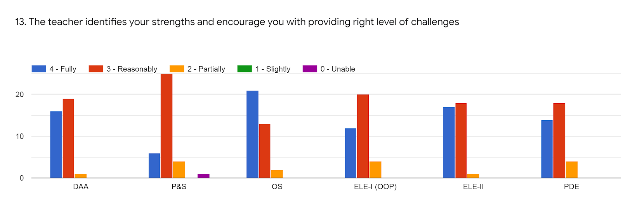

Faculty | MRM | MSY | MV | GPL | BPR | MV | %
Subject | DAA | PS | OS | OOP(ELE-I) | NM(ELE-II) | PD
85 -100 % | 17 | 6 | 21 | 13 | 17 | 14 | 0.47%
70 – 84 % | 18 | 25 | 13 | 20 | 18 | 18 | 60%
55 – 69 % | 1 | 4 | 2 | 3 | 1 | 4 | 8%
30 – 54 % | 0 | 0 | 0 | 0 | 0 | 0 | 0%
0- Below 30 % | 0 | 1 | 0 | 0 | 0 | 0 | 0.5%

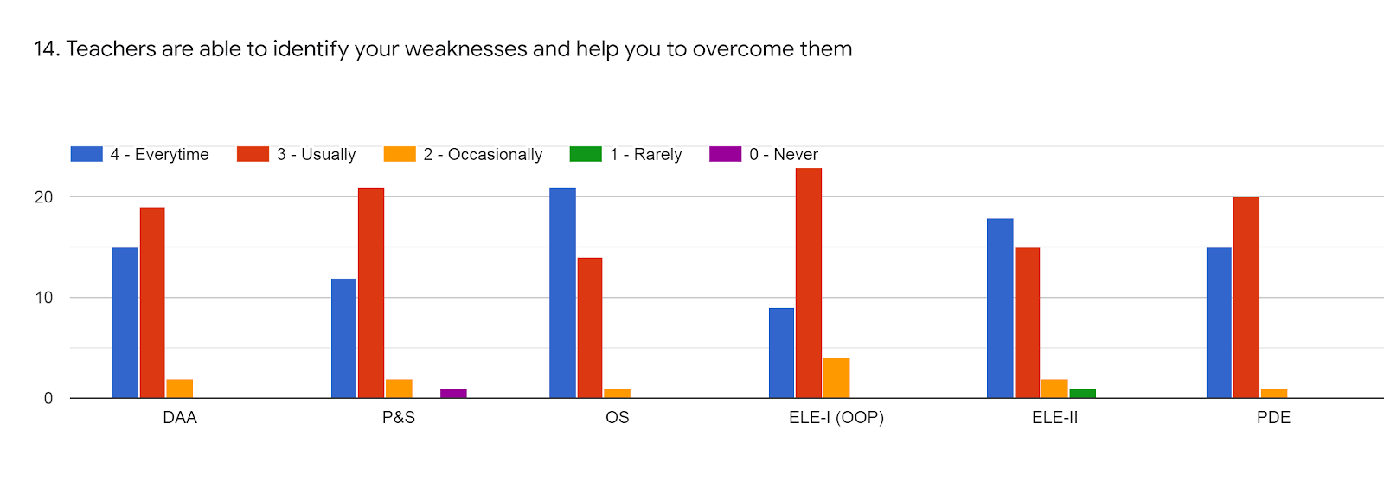

Faculty | MRM | MSY | MV | GPL | BPR | MV | %
Subject | DAA | PS | OS | OOP(ELE-I) | NM(ELE-II) | PD
85 -100 % | 16 | 11 | 21 | 9 | 18 | 15 | 48%
70 - 84 % | 18 | 22 | 14 | 23 | 15 | 20 | 60%
55 – 69 % | 2 | 2 | 1 | 4 | 2 | 1 | 6%
30 – 54 % | 0 | 0 | 0 | 0 | 1 | 0 | 0.5%
0- Below 30 % | 0 | 1 | 0 | 0 | 0 | 0 | 0.5%

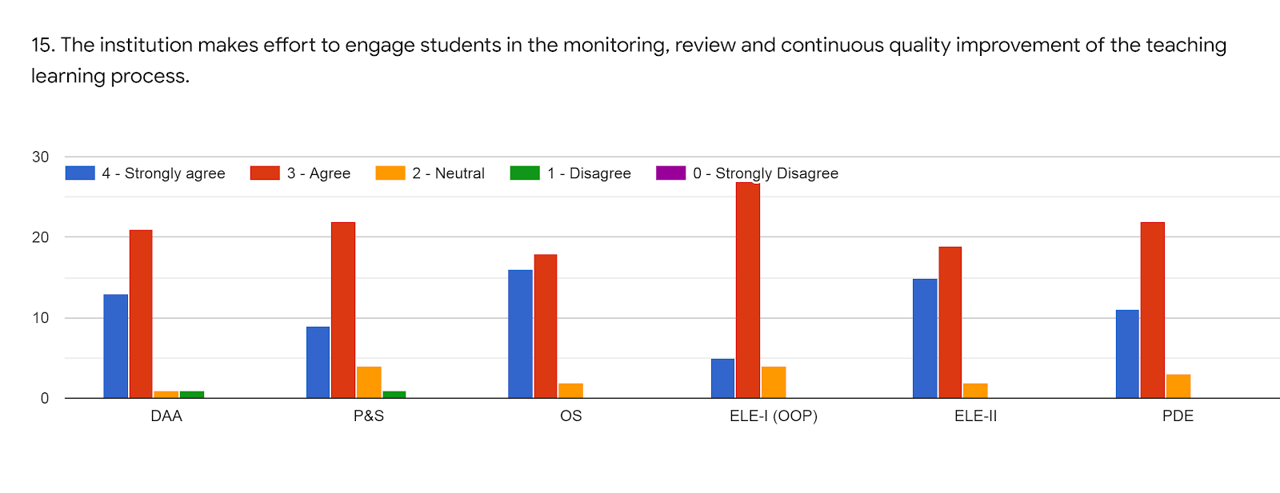

Faculty | MRM | MSY | MV | GPL | BPR | MV | %
Subject | DAA | PS | OS | OOP(ELE-I) | NM(ELE-II) | PD
85 -100 % | 14 | 9 | 16 | 5 | 15 | 11 | 37%
70 - 84 % | 20 | 23 | 18 | 27 | 19 | 22 | 69%
55 – 69 % | 1 | 3 | 2 | 4 | 2 | 3 | 8%
30 – 54 % | 1 | 1 | 0 | 0 | 0 | 0 | 1%
0- Below 30 % | 0 | 0 | 0 | 0 | 0 | 0 | 0%

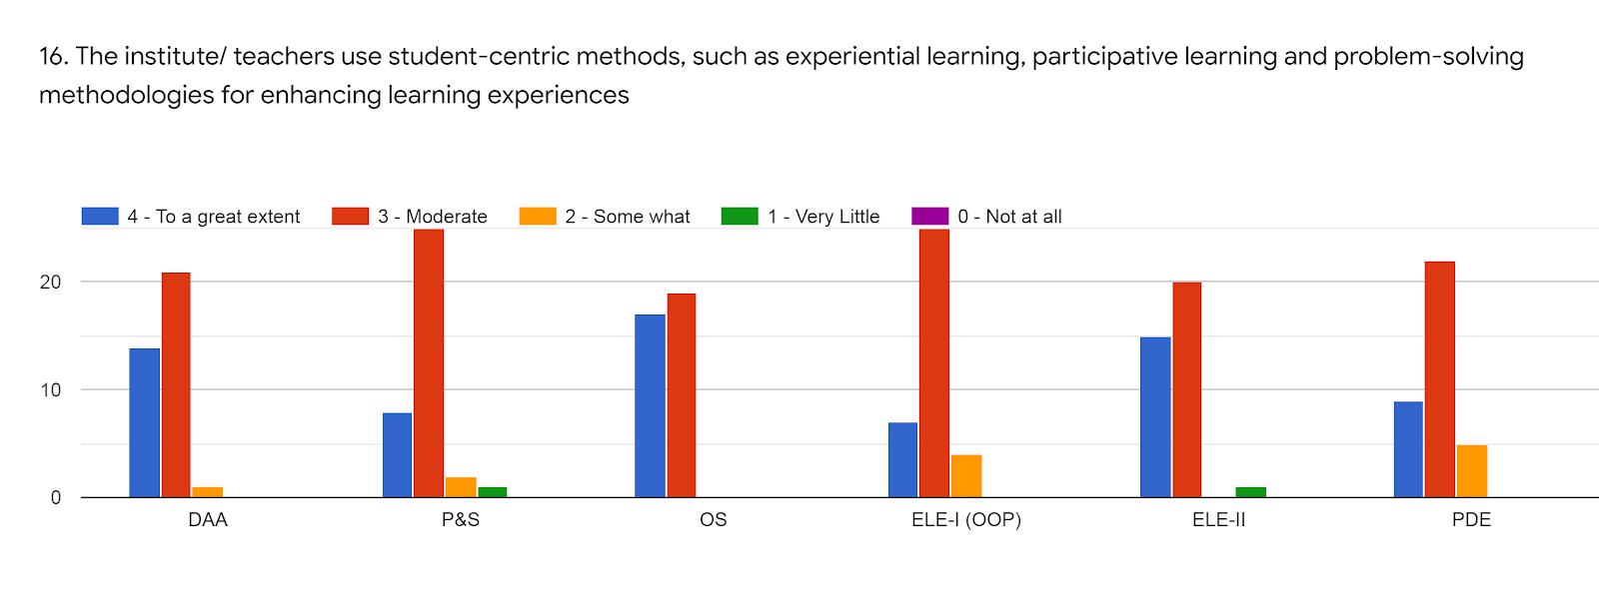

Faculty | MRM | MSY | MV | GPL | BPR | MV | %
Subject | DAA | PS | OS | OOP(ELE-I) | NM(ELE-II) | PD
85 -100 % | 12 | 8 | 17 | 7 | 15 | 9 | 36%
70 - 84 % | 23 | 25 | 19 | 25 | 20 | 22 | 72%
55 – 69 % | 1 | 2 | 0 | 4 | 0 | 5 | 6%
30 – 54 % | 0 | 1 | 0 | 0 | 1 | 0 | 1%
0- Below 30 % | 0 | 0 | 0 | 0 | 0 | 0 | 0%

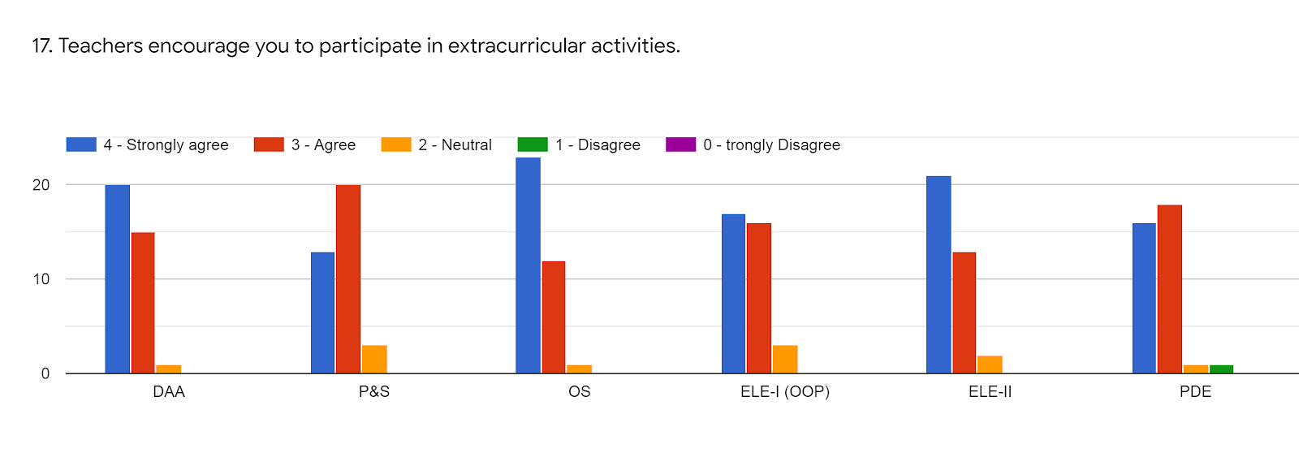

Faculty | MRM | MSY | MV | GPL | BPR | MV | %
Subject | DAA | PS | OS | OOP(ELE-I) | NM(ELE-II) | PD
85 -100 % | 20 | 13 | 22 | 17 | 20 | 17 | 58%
70 - 84 % | 15 | 20 | 13 | 16 | 14 | 17 | 51%
55 – 69 % | 1 | 3 | 1 | 3 | 2 | 1 | 5%
30 – 54 % | 0 | 0 | 0 | 0 | 0 | 1 | 0.5%
0- Below 30 % | 0 | 0 | 0 | 0 | 0 | 0 | 0%

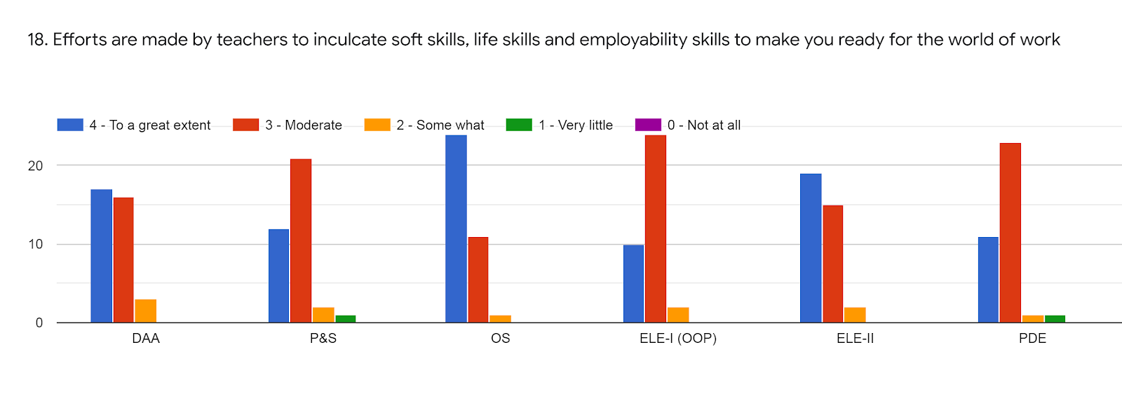

Faculty | MRM | MSY | MV | GPL | BPR | MV | %
Subject | DAA | PS | OS | OOP(ELE-I) | NM(ELE-II) | PD
85 -100 % | 17 | 12 | 22 | 10 | 19 | 12 | 49%
70 - 84 % | 16 | 21 | 13 | 24 | 15 | 22 | 60%
55 – 69 % | 3 | 2 | 1 | 2 | 2 | 1 | 5%
30 – 54 % | 0 | 1 | 0 | 0 | 0 | 1 | 1%
0- Below 30 % | 0 | 0 | 0 | 0 | 0 | 0 | 0%

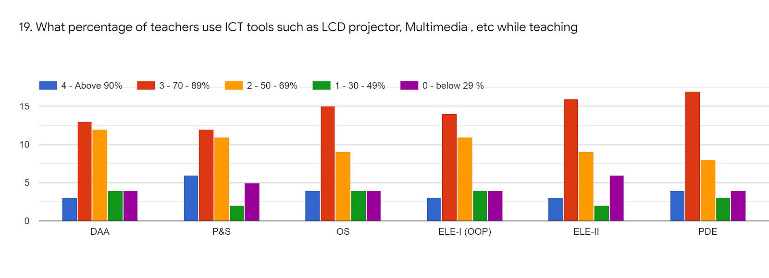

Faculty | MRM | MSY | MV | GPL | BPR | MV | %
Subject | DAA | PS | OS | OOP(ELE-I) | NM(ELE-II) | PD
85 -100 % | 3 | 6 | 4 | 2 | 3 | 4 | 11%
70 - 84 % | 13 | 13 | 15 | 14 | 17 | 16 | 47%
55 – 69 % | 11 | 10 | 9 | 12 | 8 | 7 | 30%
30 – 54 % | 4 | 2 | 4 | 4 | 2 | 4 | 10%
0- Below 30 % | 4 | 4 | 4 | 4 | 6 | 5 | 14%

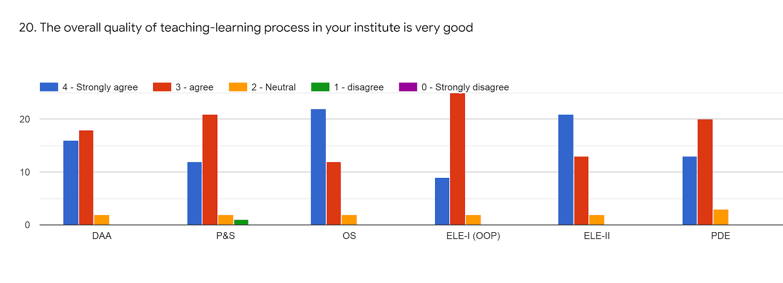

Faculty | MRM | MSY | MV | GPL | BPR | MV | %
Subject | DAA | PS | OS | OOP(ELE-I) | NM(ELE-II) | PD
85 -100 % | 15 | 12 | 20 | 8 | 20 | 13 | 47%
70 - 84 % | 19 | 21 | 14 | 26 | 14 | 20 | 61%
55 – 69 % | 2 | 2 | 2 | 2 | 2 | 3 | 7%
30 – 54 % | 0 | 1 | 0 | 0 | 0 | 0 | 0.5%
0- Below 30 % | 0 | 0 | 0 | 0 | 0 | 0 | 0%

- Give 3 observations/ suggestions to improve the overall teaching-learning experience of respective teachers.

  - Sometimes I m unable to join the online lecture due to weak network and connection error.
  - Phone overheated during online lectures and immediately power off itself. What can I do if this things affects on my presence.
  - We can Use another media like Google Class Room. Some network problem occurs during online lectures. Thank you to all members of AGCE team for taking extra efforts during this tough time
  - Make some project oriented Assignment & submission work rather than writing
  - Practical Oriented Learning is expected
  - In our institute the process of teaching learning process is good as compared to the other institutes.
All teachers give their best.

OVERALL ANALYSIS

Sub | Faculty | Appreciation | Suggestions for  improvement
DAA | MRM | Prepares well for lecture, Efforts are made by teachers to inculcate soft skills, life skills and employability skills to make you ready for the world of work | Field Visits, Use of ICT
PS | MSY | Teacher illustrate through example, Fairness of the internal evaluation process by the teachers, Good teaching and mentoring process | Field Visits, Use of ICT
OS | MV | Efforts are made by teachers to inculcate soft skills, life skills and employability skills to make you ready for the world of work | Field Visits
OOP | GPL | Mentor does a necessary follow-up with as assigned task to you, Teacher illustrates the concepts through examples and applications | Field Visits
NM | BPR | Teacher illustrates the concepts through examples and applications, Teacher identifies your strengths and encourage you with providing right level of challenges | Use of ICT

